**ASSIGNMENT 2.1**

**on**

**Working with Jupyter Notebooks**

**Submitted by:**

**Haseebullah Shaikh (2303.KHI.DEG.015)**

with

**Faiza Gulzar Ahmed (2303.KHI.DEG.001)**

**Dated :** 13th Apr 2023

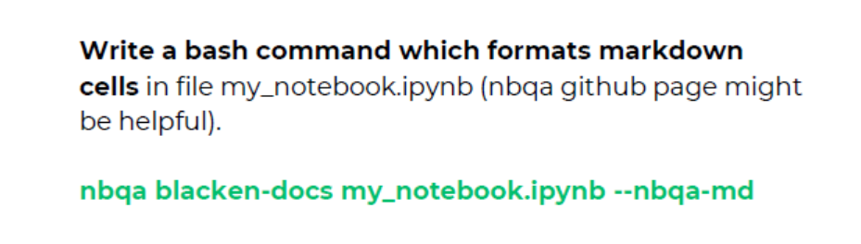**Task 01:**

**Solution:**

**Unformatted markdown file :** written code in python with spaces in syntax.

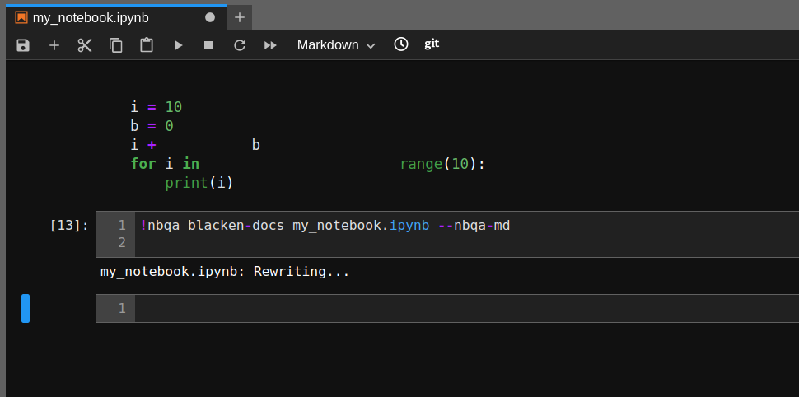**Formatted file after running provided command**

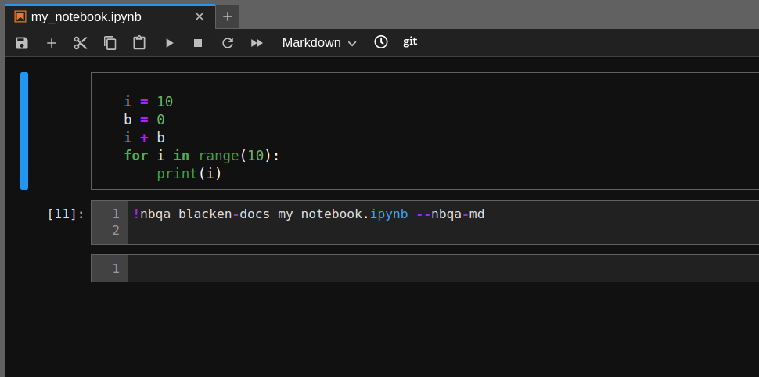

**References**

[**https://github.com/nbQA-dev/nbQA**](https://github.com/nbQA-dev/nbQA)